EXP: 7
1) How many students are registered for each course? Display the course description and the number of students registered in each course
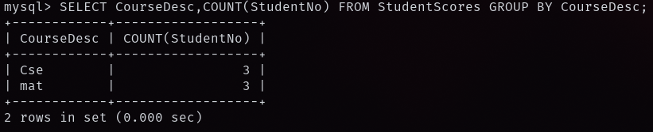
2) How many courses did each student register for?
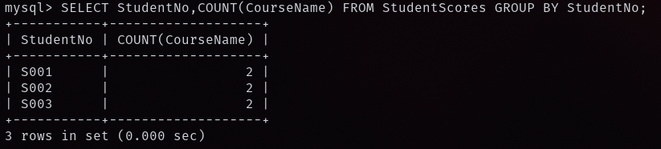
3) Retrieve Name, Gender, Mobile No of all the students in ascending order of Reg No
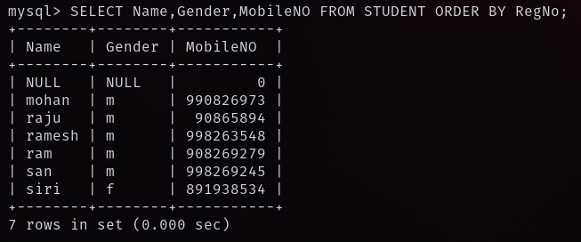
4) List the faculty members in the order of older faculty first
